The Washington Post on 07-01-2013: New Iran sanctions target industry in bid for deal curbing nuclear program
Below are my comments around this topic.
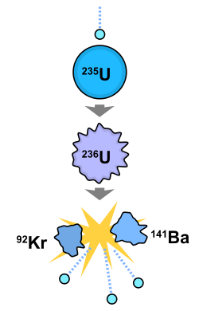
Since few years, and even being in Canada and hence far from Middle Eastern problems and most of all, safe from being injured in my body in case I stand against Iranian politics in the Middle East and mainly in Lebanon, well I used to stand with Iran scientific progresses in space and nuclear sciences since this is the right of any country to choose what are its development policies.

Arab countries of the Gulf area on the contrary, has chosen economic and technologic development using free market economies as principles, and democracy and human rights rules in their dealings among each other and in their international foreign affairs and specially truthfulness shaped with good faith in dealing with their allies of the Western countries among them France, Germany, UK, USA, Etc…
The Arabs of the Arabian Peninsula then had chosen peace and humbleness in their ways of living among their neighbours while Iran had chosen the adventure, arrogance, and predator’s behaviour in its ways of living among its neighbours in the Middle East.
Since I have respect and esteem to these main countries of the Western Hemisphere who are France, UK, Germany, Italy and USA, being myself of an extreme literal penchant and hence, an admirer of the European cultural heritage in as much as mathematics, physics, medicine, astronomy and philosophy are concerned, then I am supposed to be also an admirer of Arab, Greek and Persian cultural heritages since all human efforts in development worldwide converge to one essential aspect which is “Human Well Being!”
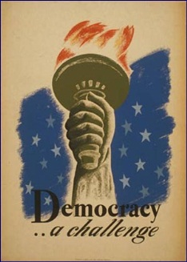
With the advent of the Syrian upraise all my esteem to Iran scientific development turned upside down, since how can we admire the scientific development of a country that at the same time is standing as a barrier in the Democratization of Syria by repressing all Syrian’s people demand for: Freedom! How can it be for a nation to have a double face and nature, can you answer me? Well, I can give a hint and this happened in Nazi Germany during WWII! While the Third Reich was parading the great Nuremberg square with majestic parades on Wagnerian music, he was at the same time carrying in the shadow the Jewish Holocaust in gas chambers and incinerators.
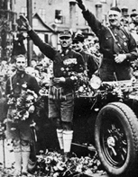
The same philosophy is being carried in Syria and Lebanon: Great Hezbollah Parades in Lebanon in harmony with a Syrian Genocide carried by Chabiha, Hezbollah and Others! In this Syrian case however, the genocide is not being carried in the shadow, since the advents of mass media diffusion technologies today, had changed the picture compared to yesterday during WWII, whereby media propagandas were restricted and sometimes absent!

