Judaism

Jewish Culture Entrepreneurship

Pictorial Representation of the Three Rotation of 180 Degrees of the Superposition of the Two
Poles Triangle of Zionism Triangle Triangles

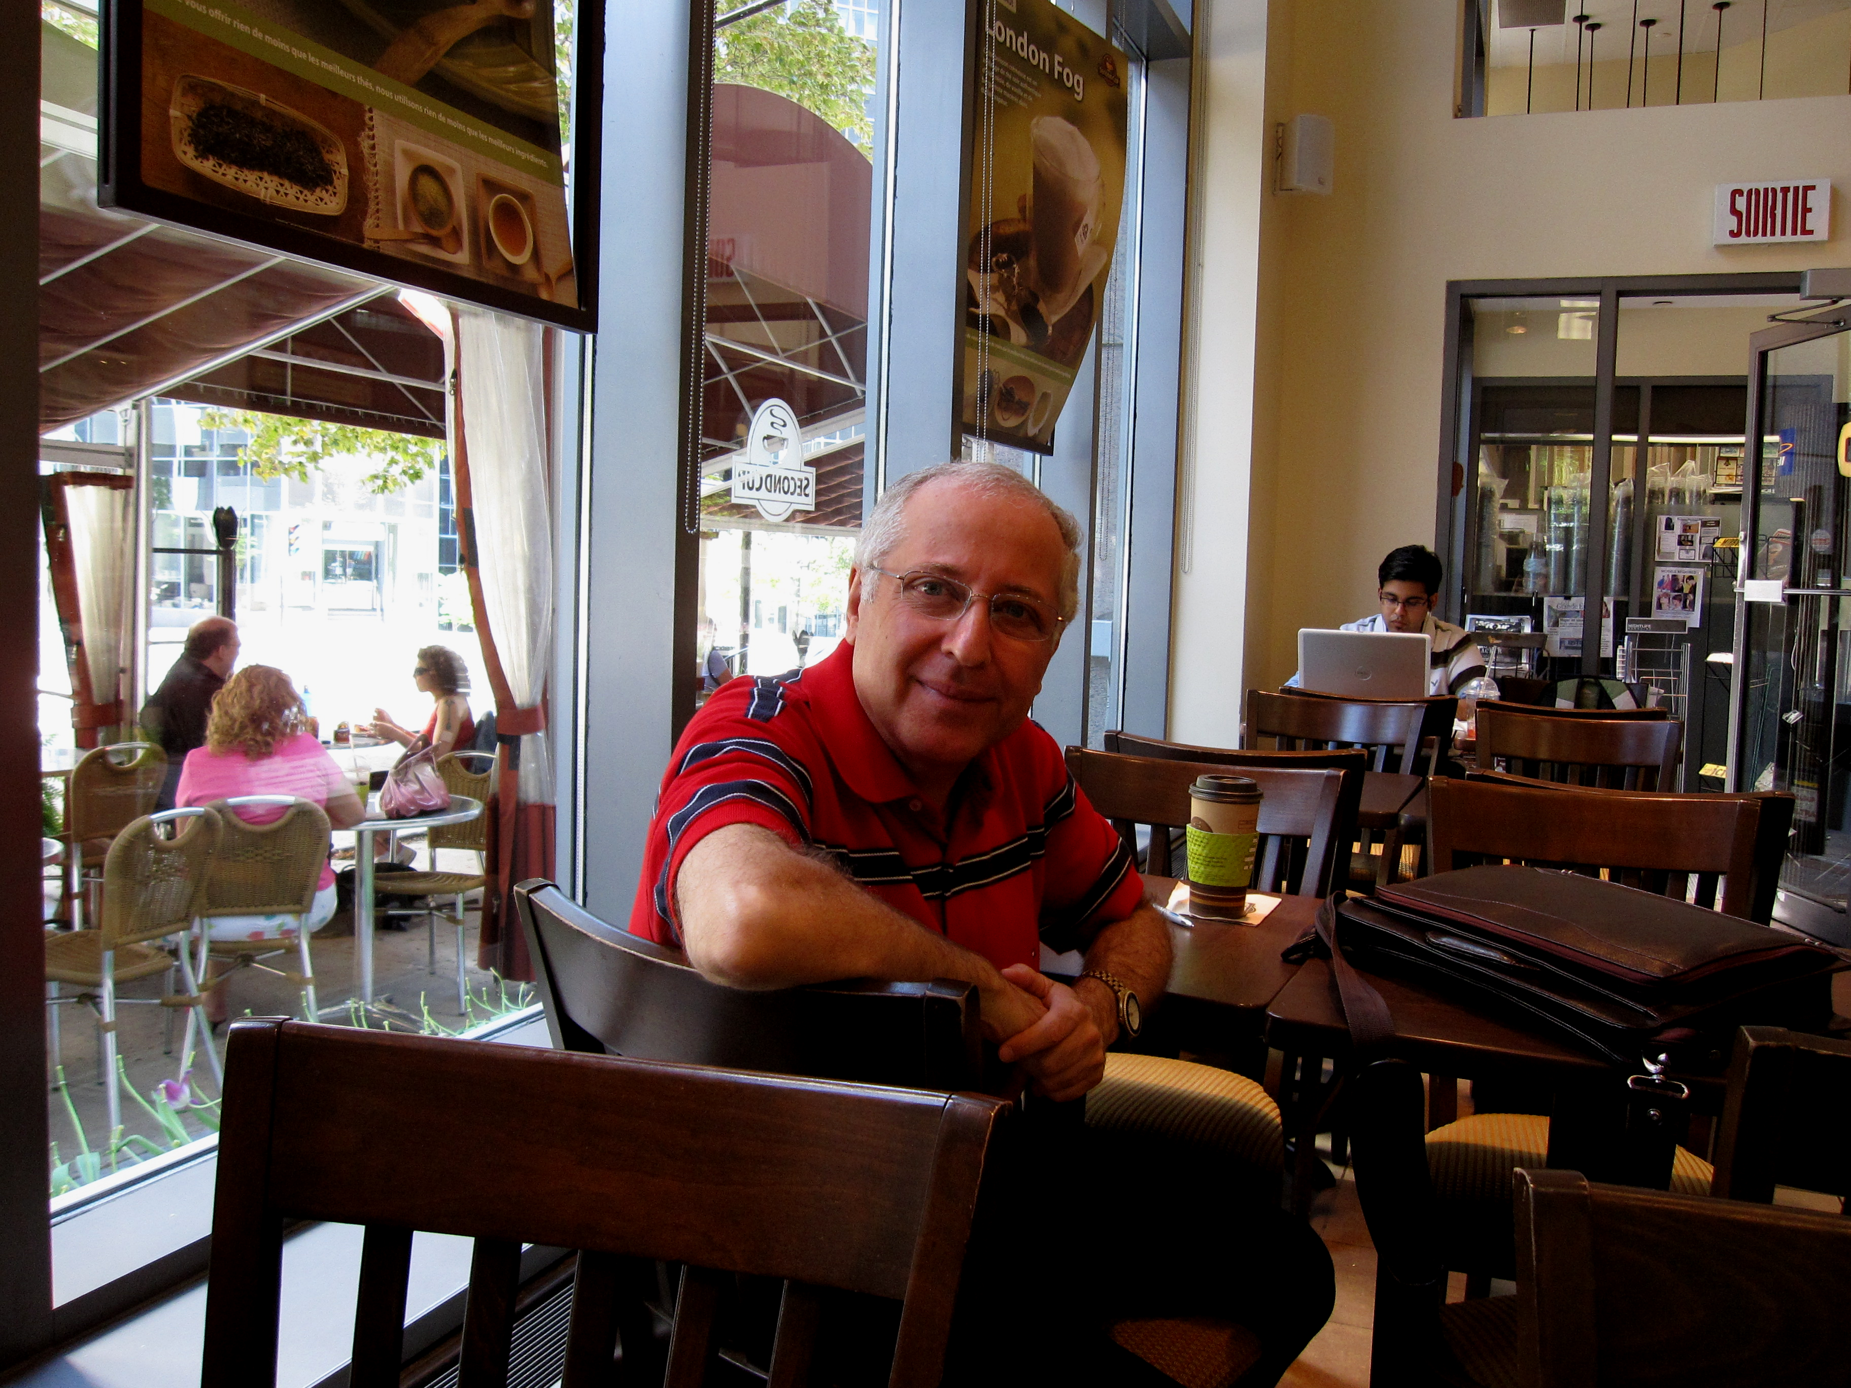
Figure1. Geometric Representation of Secular Zionism

Picture Of Hassan Saghir, PE; M.Eng(Env.)
BSc(Agr.); Dipl. Ing. Agr.
President & Director General Of Hydro-Envirosystems CO.

Religion Arabism

Arabic Culture Economic Development

Pictorial Representation of the Four Rotation by 45 Degrees of the Superposition of the Two
Poles Squarre of Arabic Nationalism Squarre block Squarre Blocks

Figure2. Geometric Representation of Secular Arabic Nationalism

