1. Technology
2. Democracy
3. Religion
4. Socialism
5. European Culture
6. European Union

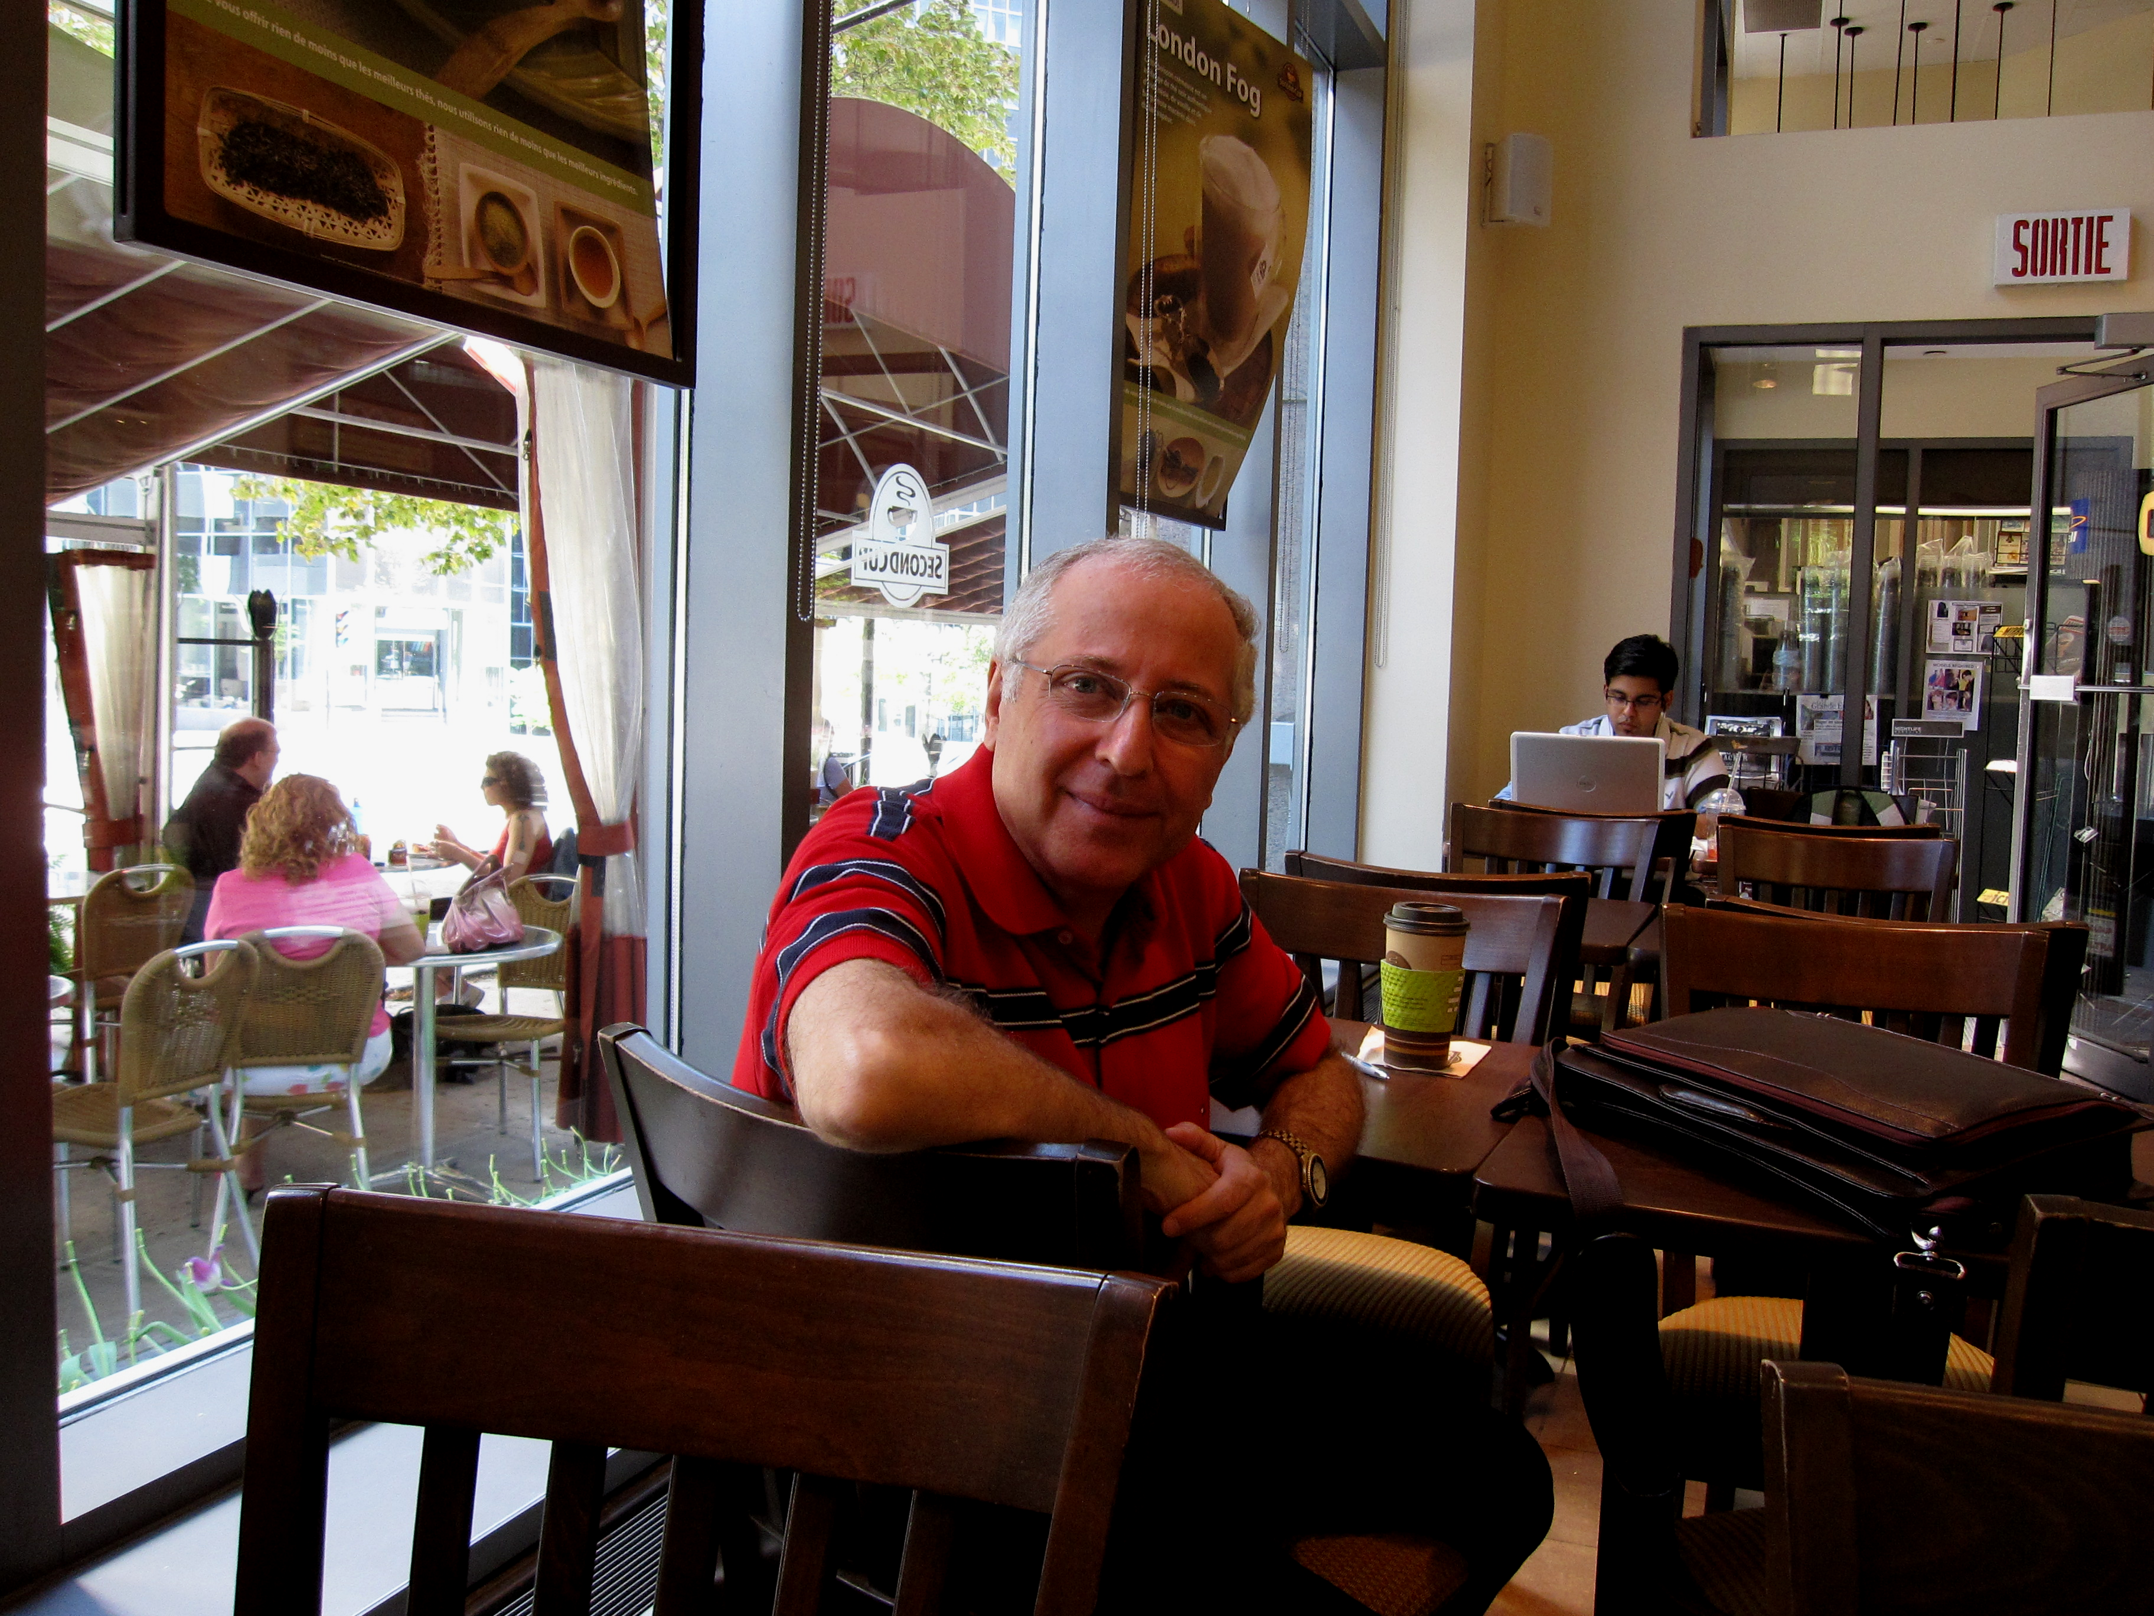

Picture Of Hassan Saghir, PE; M.Eng(Env.)
BSc(Agr.); Dipl. Ing. Agr.
President & Director General Of Hydro-Envirosystems CO.

- Religion
- Defense
- Capitalism
- Democracy
- American Union

Figure 3. The Secular European Hexagon on the upper sketch with the Secular American Pentagon on the lower sketch together with their respective foundations or poles to the left.

