The International Tribunal: Commentaries-Annex V

I will comment on this paragraph of mine:

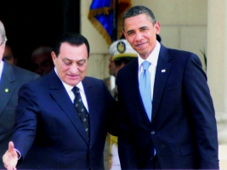
As all of us who follow the events on the Middle Eastern scene, Syria was over the years the main supporter to all sorts of revolutionary movement in the Arab world. Unfortunately, these movements were perceived in two great angle sides, depending on where each one of us stands in this equation. To most Arab people, the struggle to liberate Palestine and hence fight Israel, was a legitimate act although some times brutal, whereas to countries of the West, this was considered before as an act of terror for many years, before reaching its world legitimacy now a days, because of a world changes in people’s attitudes to each other and an over all worldwide consciousness. With this double vision of, etc....

With this recent visit which is still in progress, of President Obama to the Middle East, it was mentioned on one TV Channel, and I guess TV5 Monde, that the purpose of this visit is to reconciliate between this double vision of the Arab-Israeli conflict as have mentioned and predicted about 21/2 months ago! I mentioned the above phrase:

Unfortunately, these movements were perceived in two great angle sides, depending on where each one of us stands in this equation.

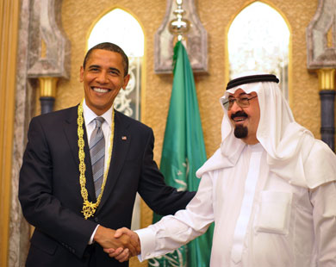
I think that I am becoming a source of intuition to Western Security and Intelligence Agencies, and I feel proud of this, in addition, I am happy while abroad to help support the Sovereignty & Democracy in my country of origin: Lebanon!

I call on all my readers and friends to follow my steps and support Lebanon in any mean available to someone: with Money if we are Rich, with Prayers if we are Religious, with Intelligence if we are Educated and Clever and with Manpower if we are Workers and Laborers!

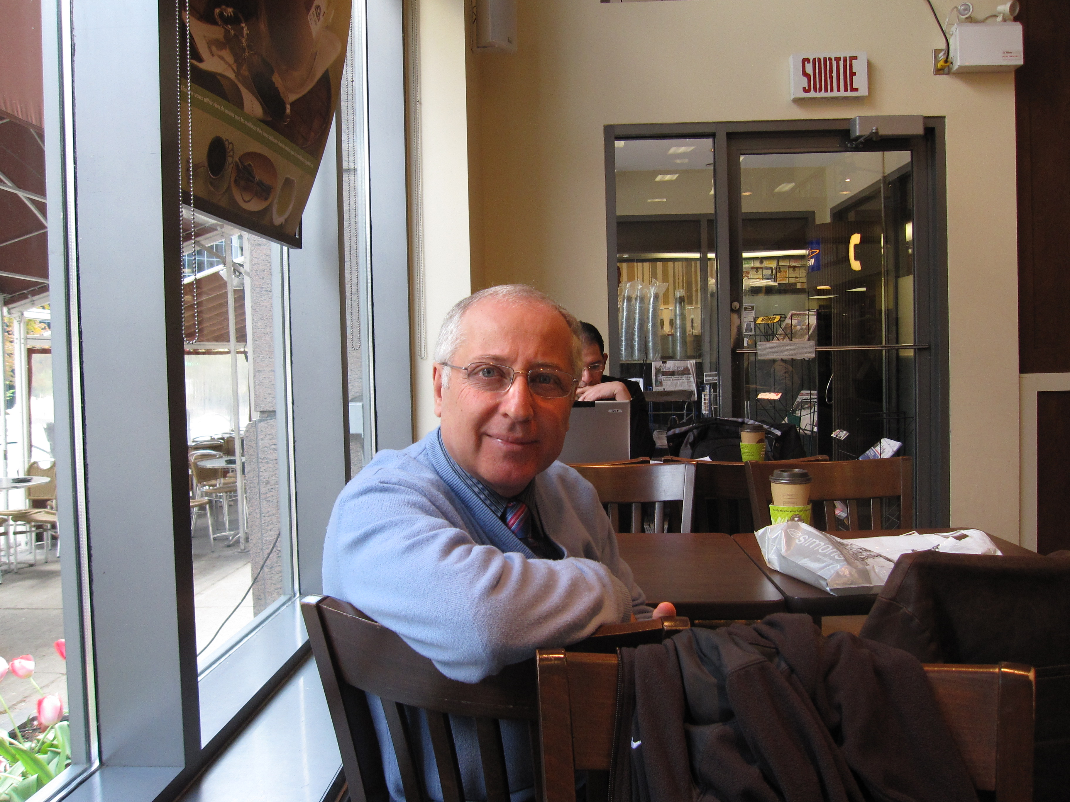
Most important, I call all my readers, if Lebanese Christians to turn their backs to Syrian Christians and their faces to Lebanese Moslems, and I call my readers if Lebanese Moslems to do the same, which is to turn their backs to Syrian Moslems and their faces to Lebanese Christians, since it has proven that the Syrian is a Syrian, and more, an Assyrian Syrian that has nothing to do with Arabism!

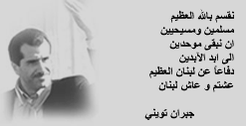
I think that this is the best way to converge with the late Martyr Gebran Tueni Solemn Affirmation Wishing to have the Lebanese Moslems and Christians Stay Assembled and United Till the End of Times, as he stated prior to his assassination few years ago.

Thank you all,
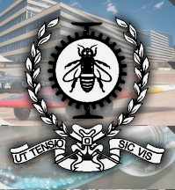

Hassan El-Saghir, PE; M.Eng (Env)

